Day 27: 21-11-2025:
Jenkin pipe line : Jenkin pipe line is a type of job which contains set of automation sets written as a code (Pipe line code) that defines how our software should be build, rest and deploy using maven or gradle or docker or other tools
Jenkin pipe line scripting process that automation CI and CD which written in Jenkinsfile
Type of files
- Declarative pipeline simple
- Scripted pipeline - full groovy base scripting language.

Creating simple pipe line job

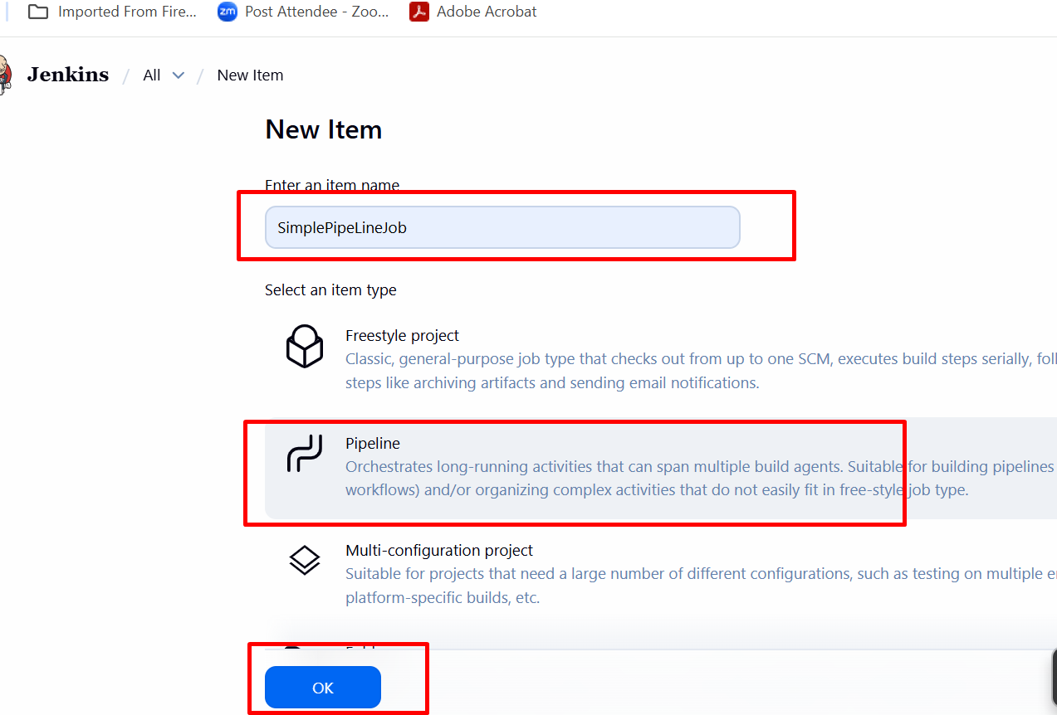
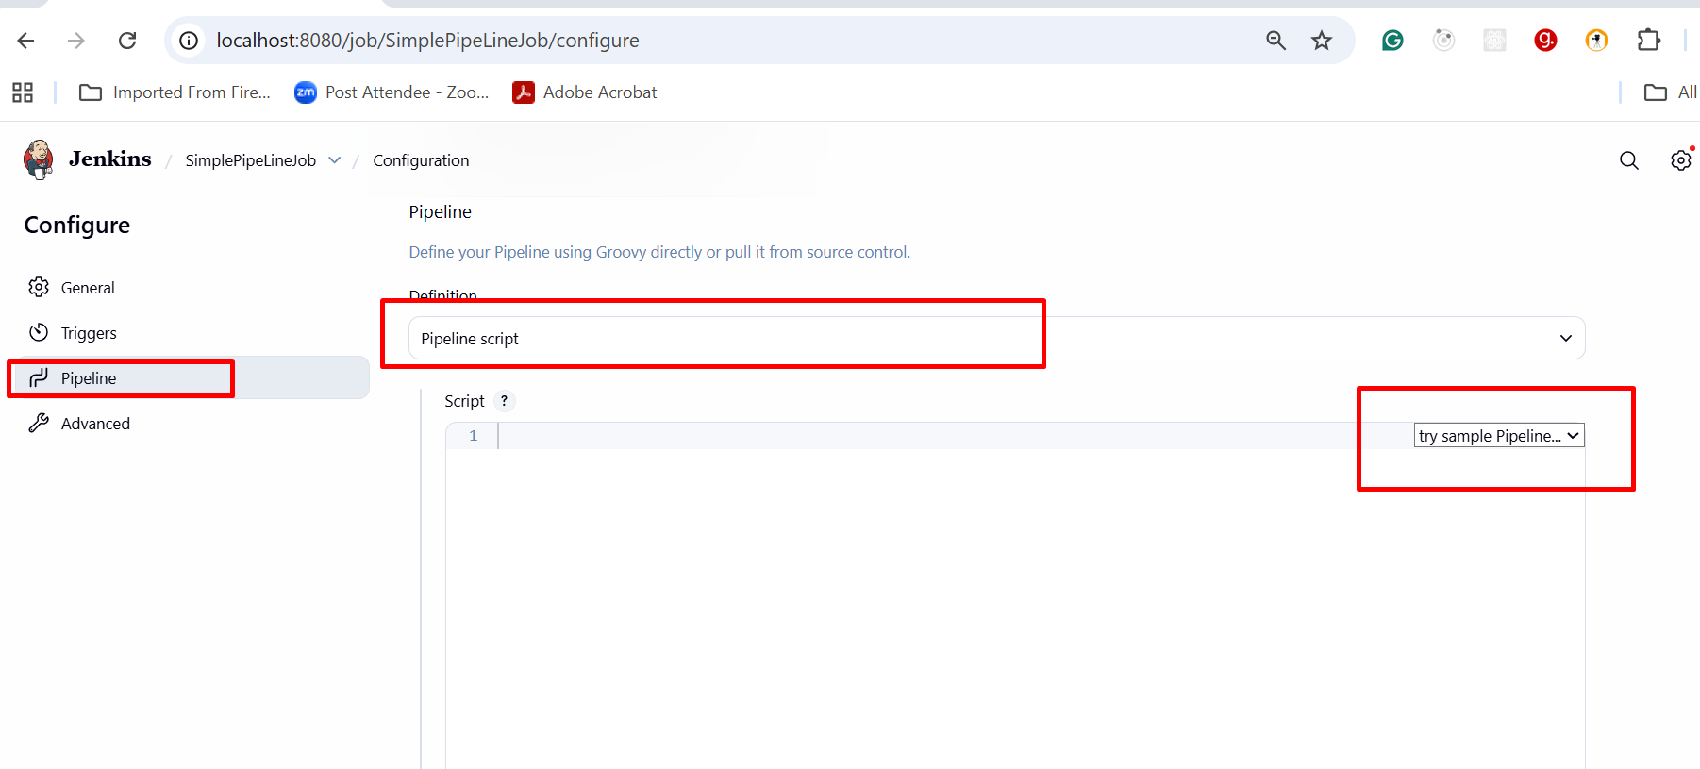

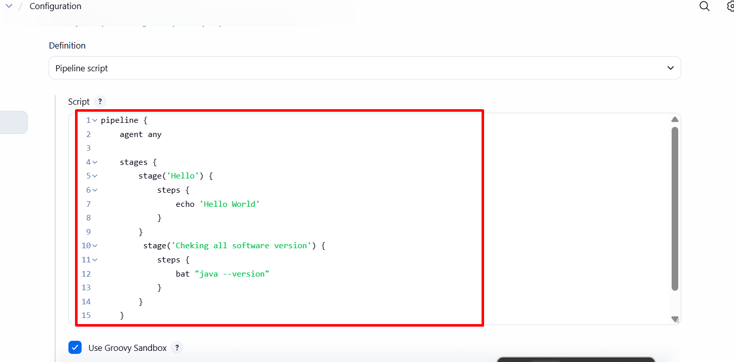

Adding other tools in Jenkin dashboard

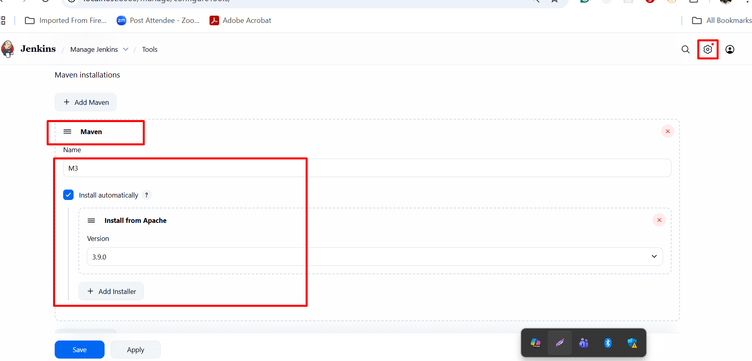

Cloud computing

Cloud computing provides as a mean by which we can access the application or tools or software or databases as utilities over the internet.

The term cloud refers to the network or internet.
Cloud computing mainly divided into 2 types base upon type of service they provide.

- Deployment model : this model defines the type of access the cloud provider.
  - Public cloud provider: these providers provide a features to access publicly available.
  - private cloud provider : these type of model maintain by organizations.
  - hybrid cloud provider: combination of public and provide cloud models.

  - community cloud provider: generally open source technologies.

- Service model : are the reference model on which the cloud computing is based these can be categorized 3 types.
  - IaaS : Infrastructure as a Service : Software and Hardware
  - PaaS : Platform as a Service : we develop the application we need server or platform their we can deploy the application.
  - SaaS: Software as a Service:

Top cloud provider
AWS
Azure
Google

AWS : Amazon Web Service:
S3 Module : S3(Simple Storage Service) it is like google drive which help to share the any of data.
It is cloud or network folder which to share any type of data.
S3 Bucket : A bucket is a top level directory or container which contains more than one folder as well as files.
Object : each file you upload in S3 bucket consider as S3 objects.
Which contains key-value pairs (key file name and path), value file data) meta-data (size, type of file, permission etc)

Region : you can choose the region to store your data.

AWS E2 instance : Elastic Compute Cloud. Using this module we can create virtual server. while creating EC2 instance you can set the configuration
- Which OS.
- OS configuration RAM, memory and mother board etc.
- Number of machine with same configuration.
Once you created this EC2 instance it provide public as well private IP Address(Dynamic IP Address).
Before running any application we need to installed required software in EC2 instance and run the application. But if we run any application generally web application develop using any language this application ready to give service using public ip address.
If we want communicate more than one machine or EC2 instance we can take the help private IP Address.

Step to create the EC2 instance

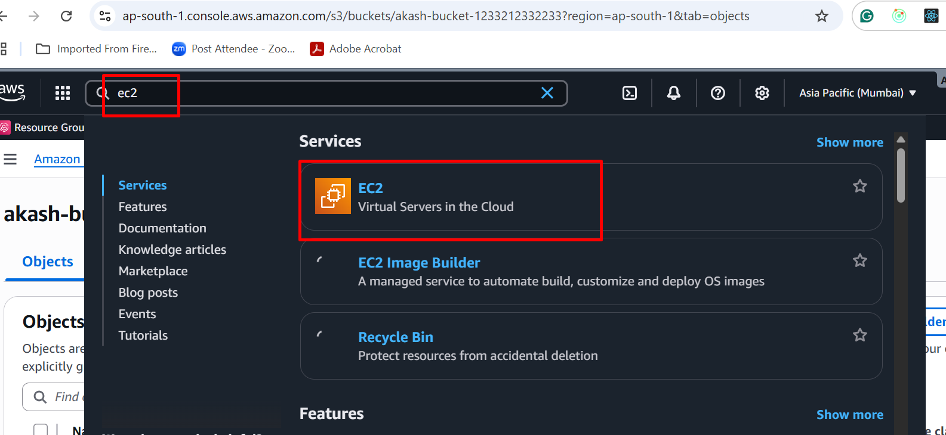

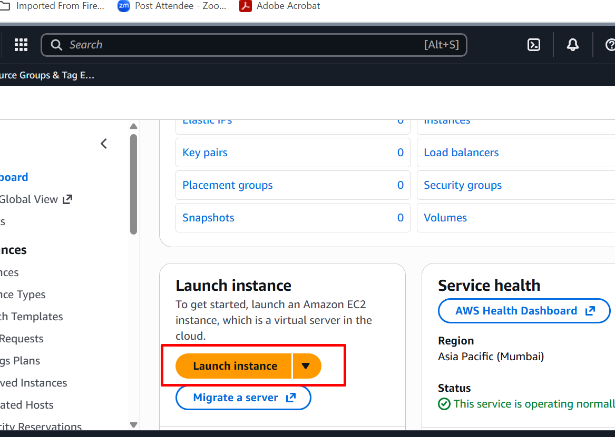

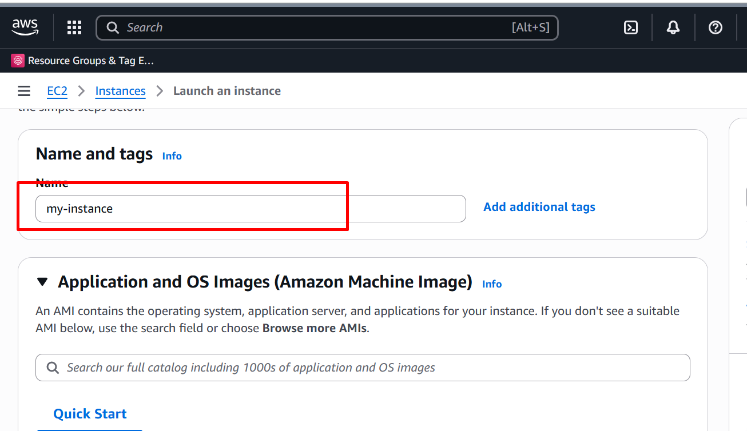

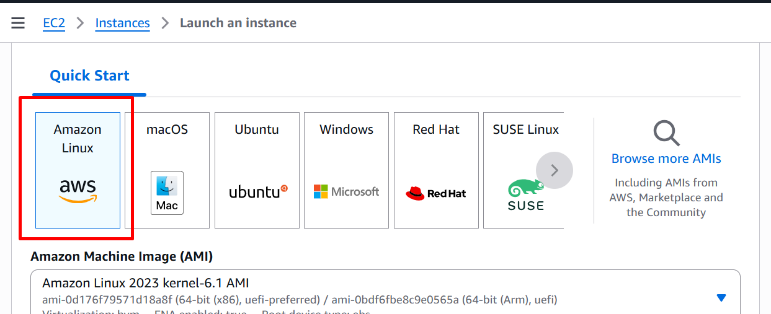

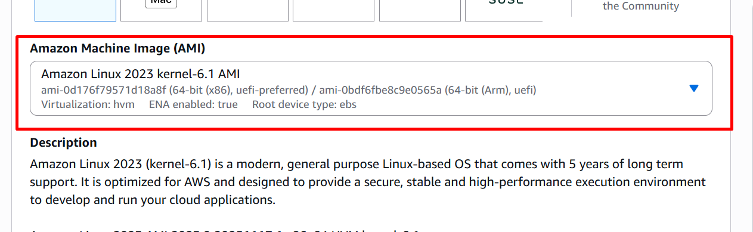

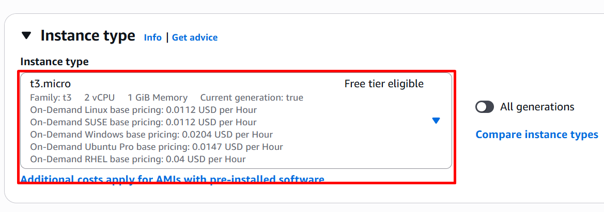

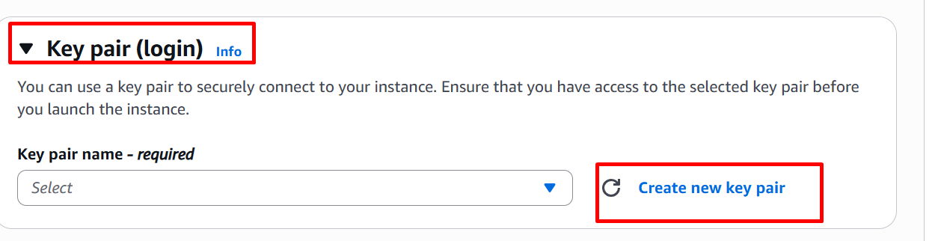

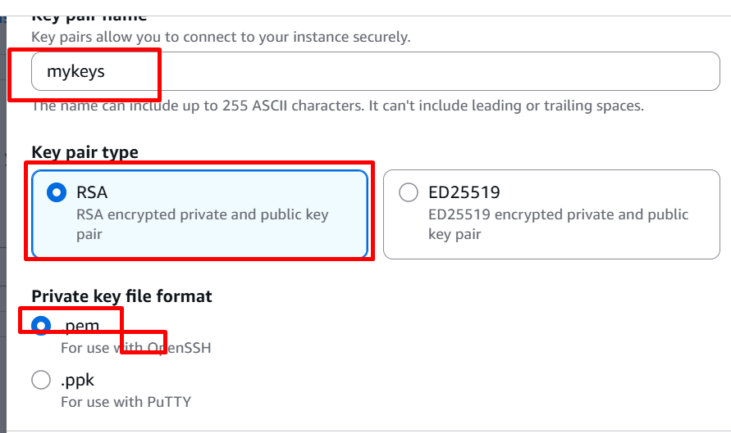

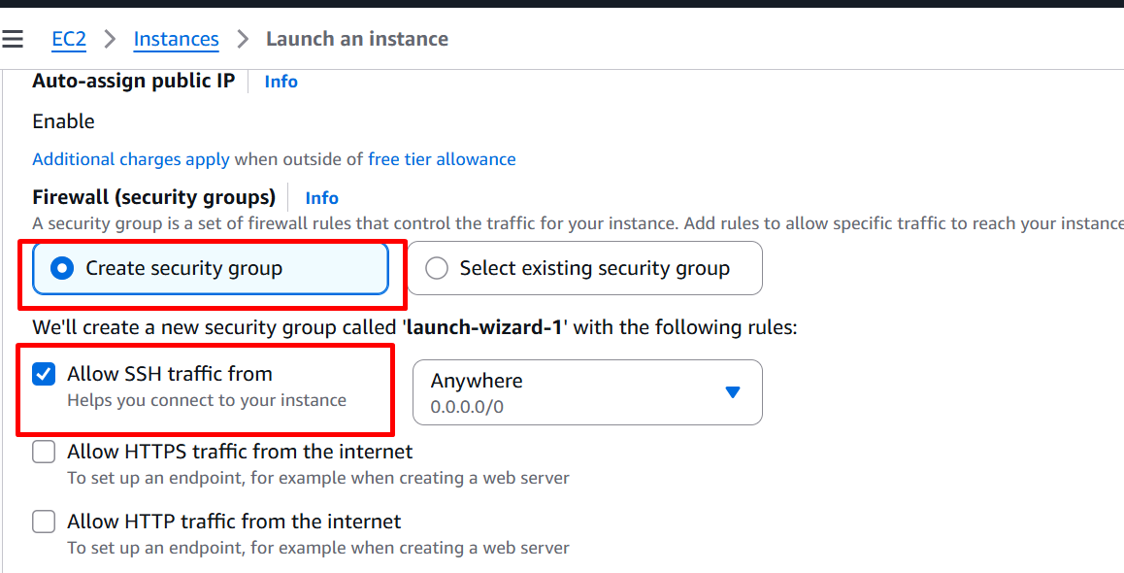

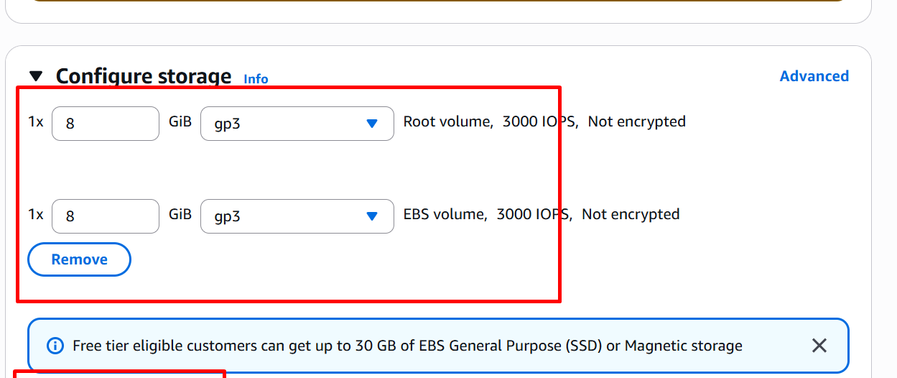

Click on launch instance

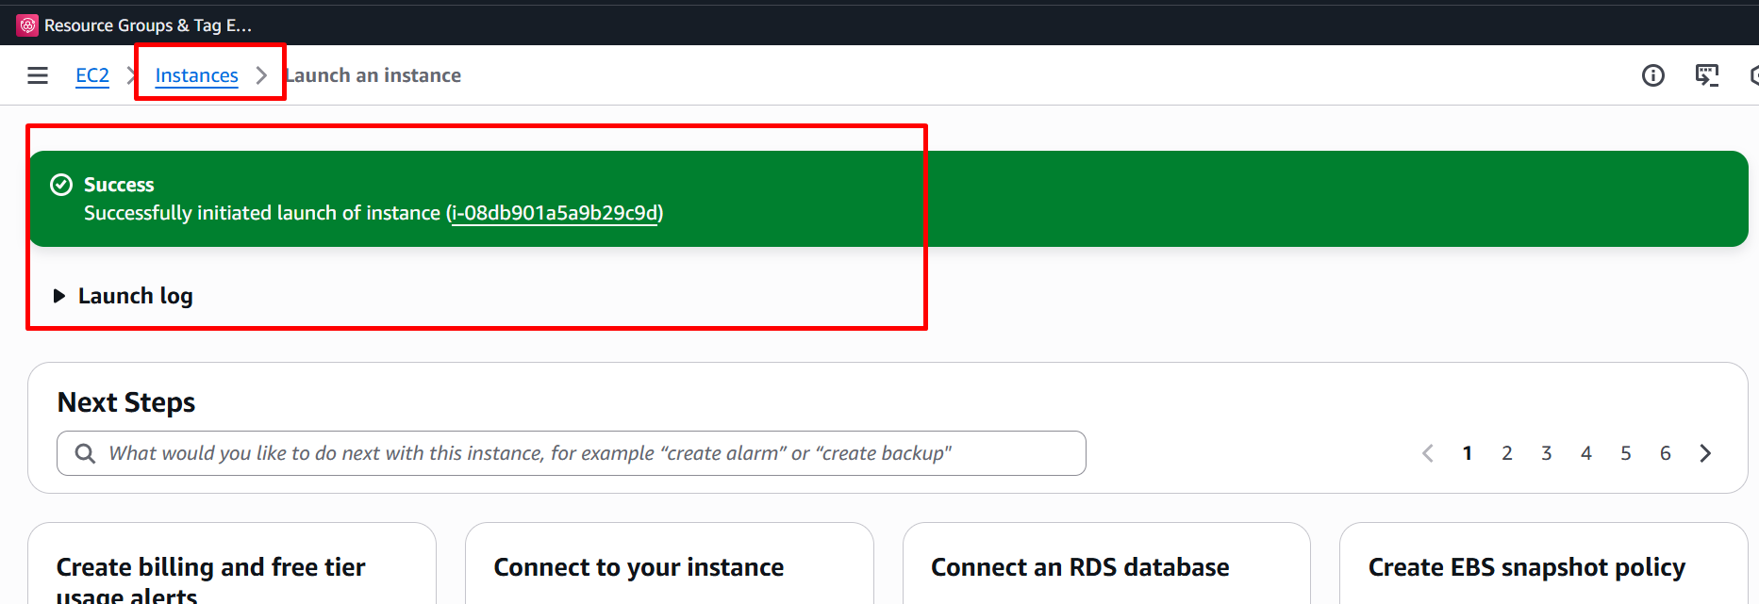

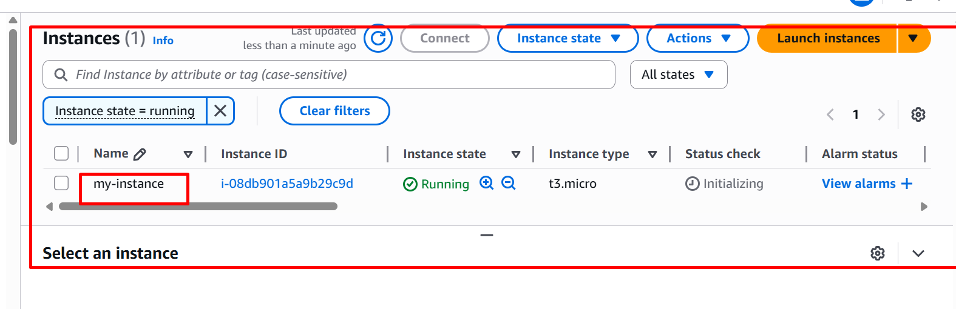

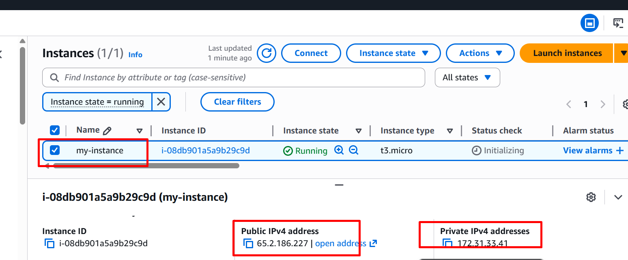

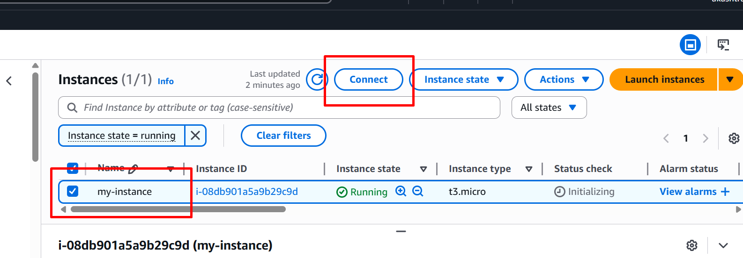

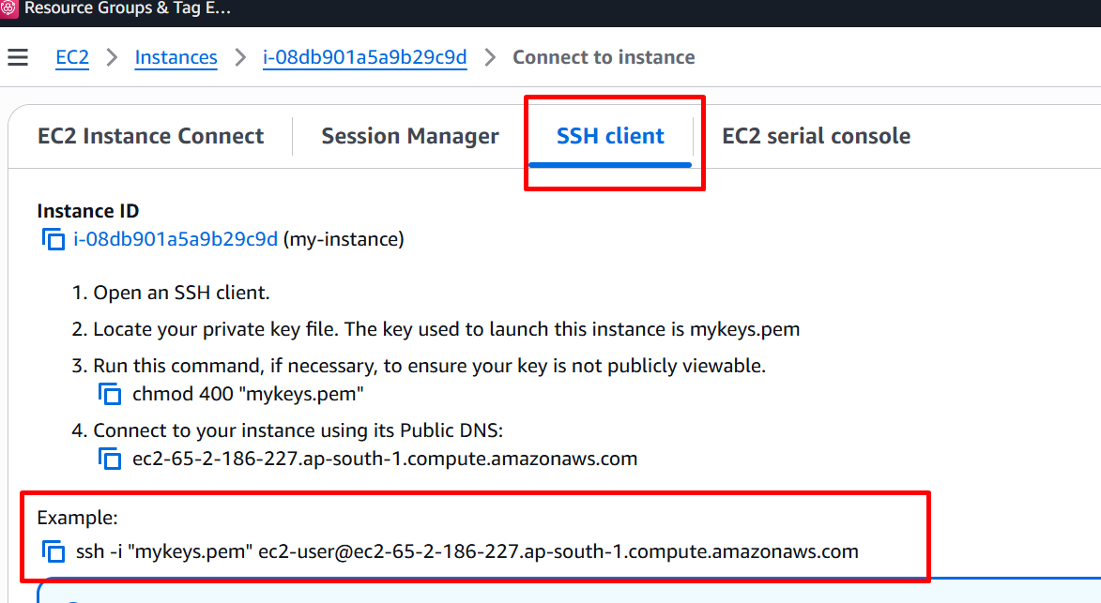

Right click inside a folder in place filename.pem key file present
Open the git bash

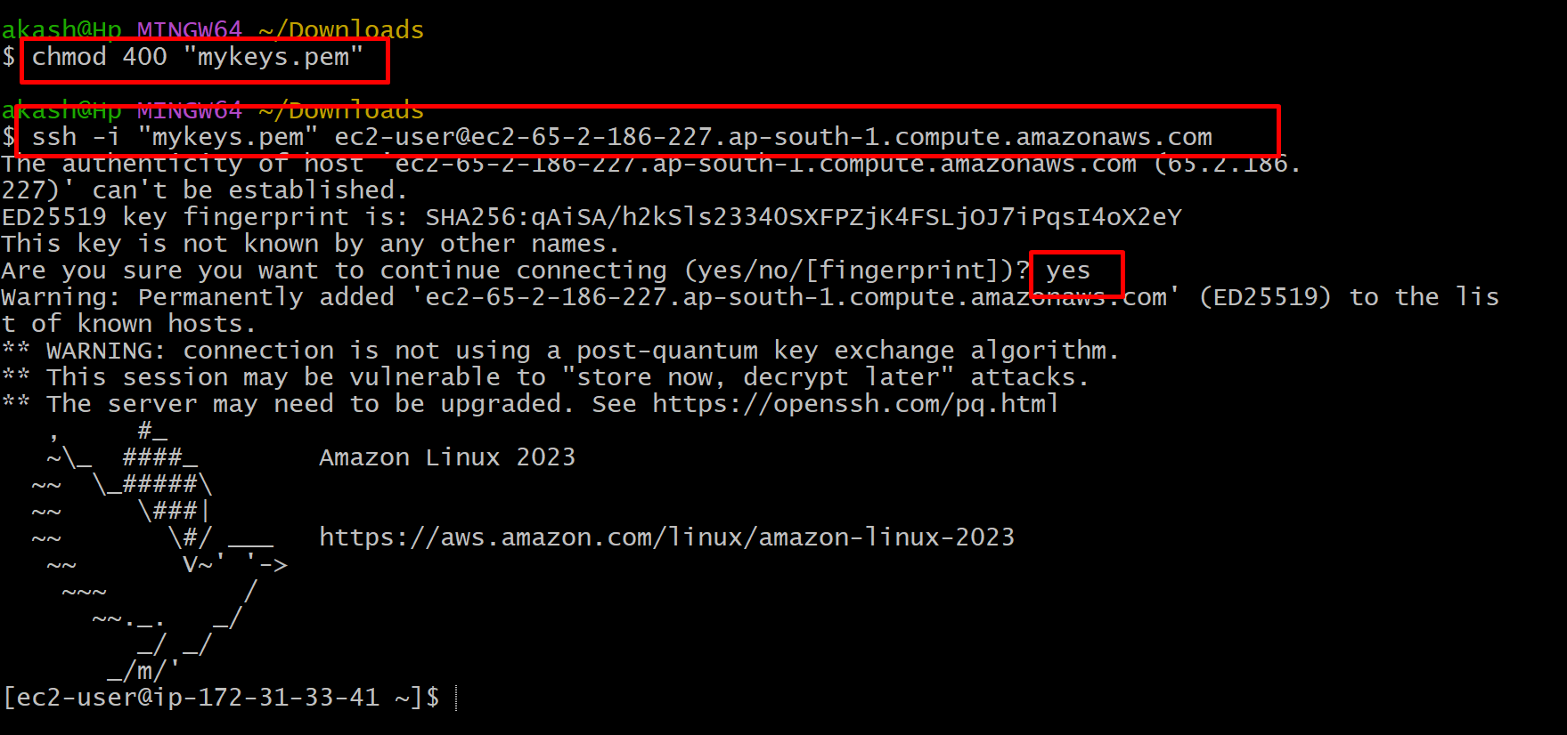

Below command to update EC2 instance
sudo yum -y update

to install the java run below command

sudo yum install java-17

please verify java

java -version

download spring boot jar file from s3 bucket to EC2 instance

wget URL

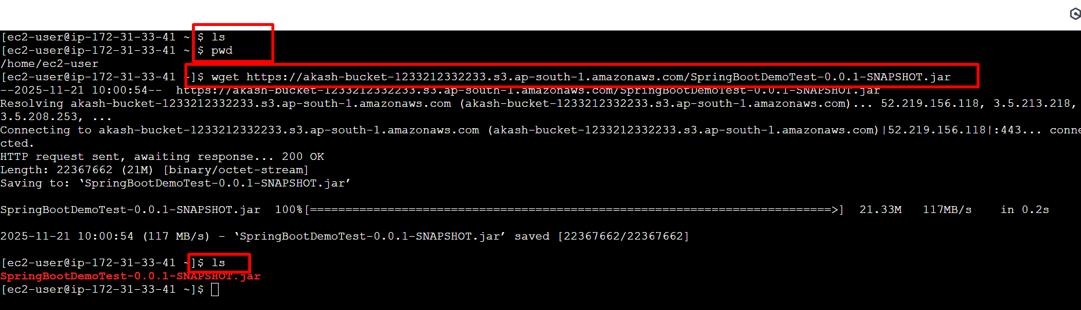

Run the jar file using java command

